https://wiki.tcsbank.ru/pages/viewpage.action?pageId=577597899
Получение писем
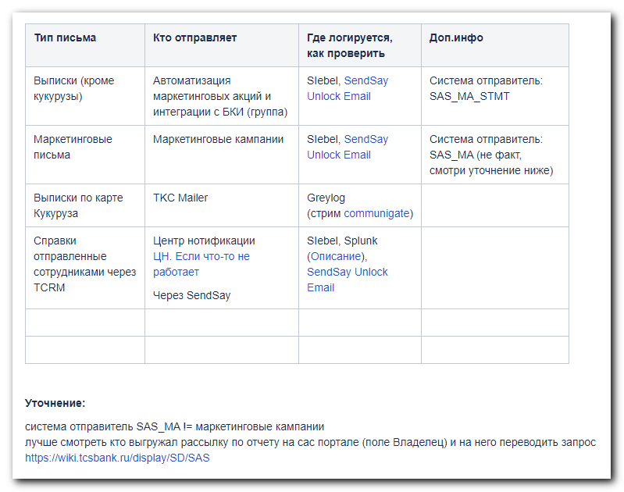
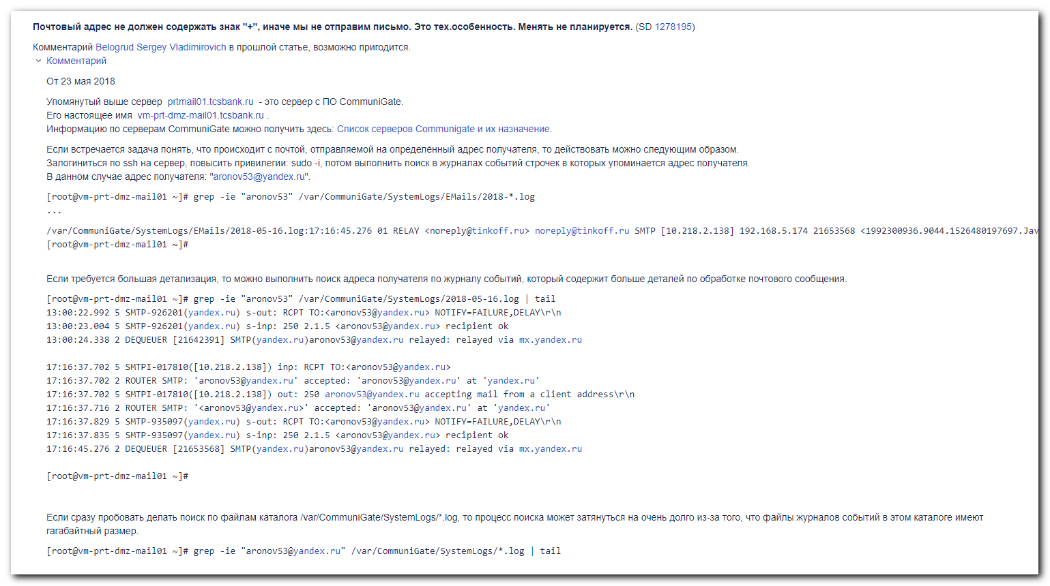

https://wiki.tcsbank.ru/pages/viewpage.action?pageId=15475914
Список серверов Communigate и их назначение

#
# Here is a stream, where could be found information about emails.
#
https://ha-graylog.tcsbank.ru/streams/5b2cc69632f0674c83d21d44/search

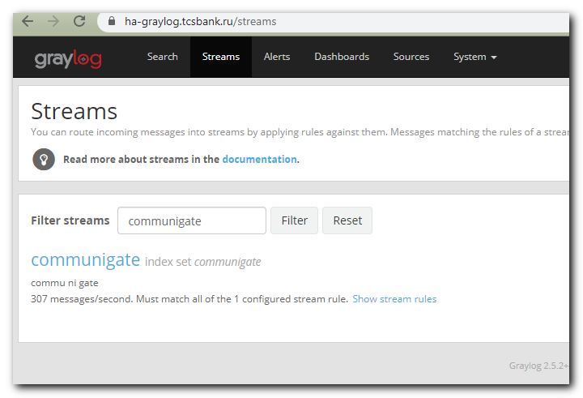

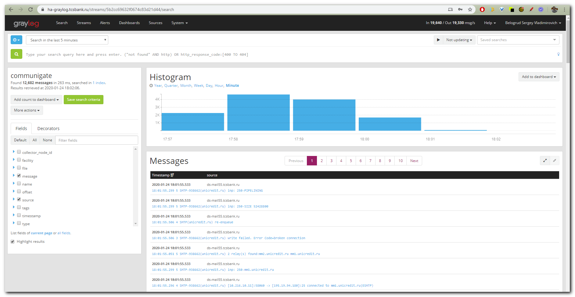

#
# 20200117
# Here is an example of wrong type of task.
# Here asked to find logs about received email from outside to us.
# But our Communigate servers work as sender list of emails from local address to outside.
#

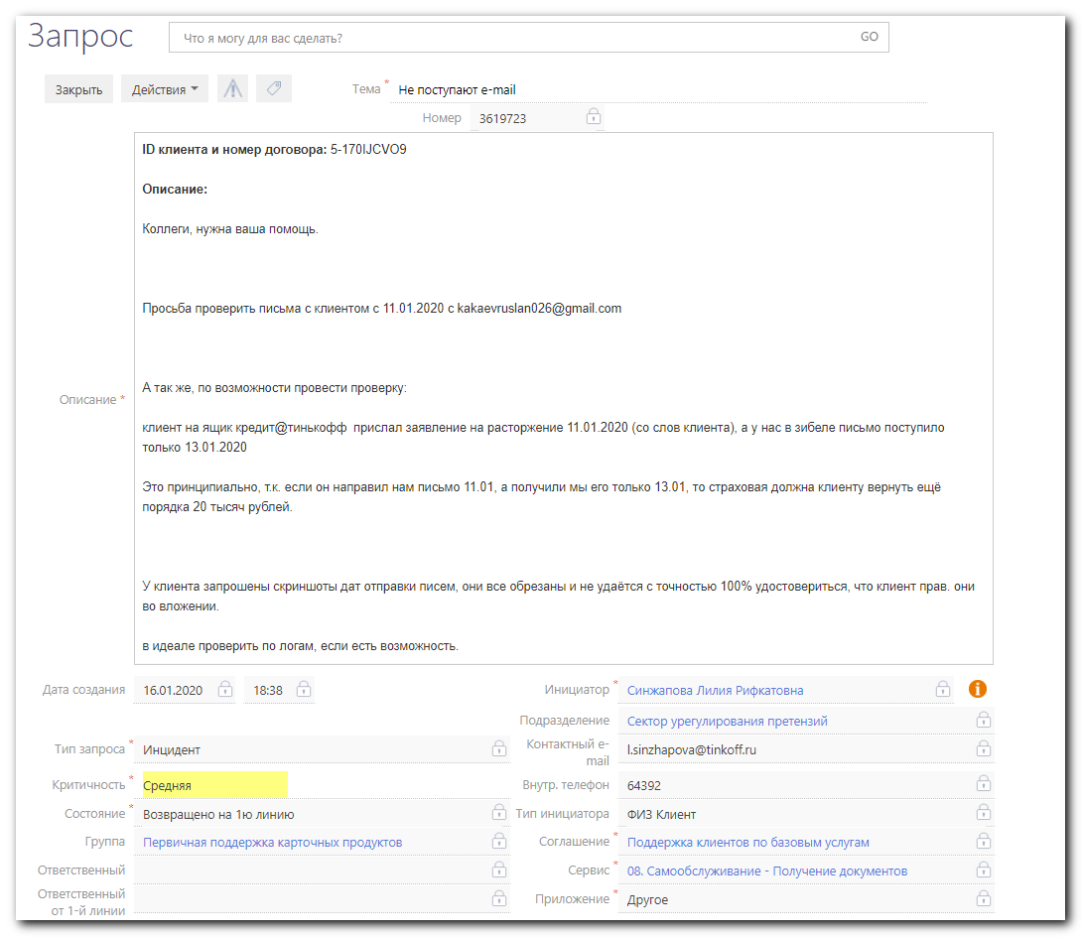
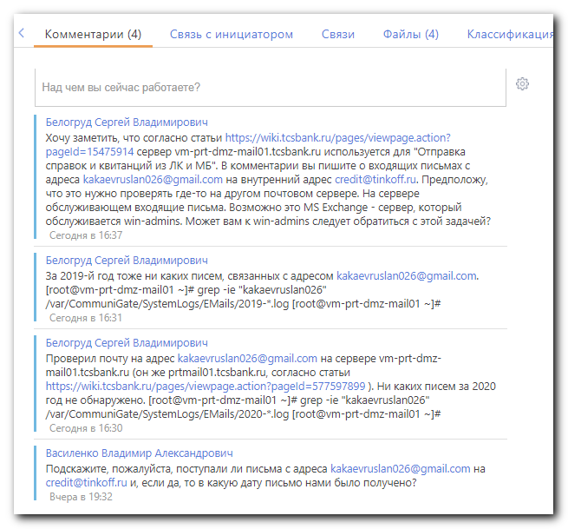

[root@vm-prt-dmz-mail01 ~]# grep -ie "kakaevruslan026" /var/CommuniGate/SystemLogs/EMails/2020-*.log
[root@vm-prt-dmz-mail01 ~]# grep -ie "kakae" /var/CommuniGate/SystemLogs/EMails/2020-*.log
/var/CommuniGate/SystemLogs/EMails/2020-01-09.log:17:32:13.652 01 RELAY <noreply@tinkoff.ru> noreply@tinkoff.ru SMTP [10.218.8.18] 192.168.5.174 51472259 <1462193576.12591.1578580333334.JavaMail.noreply@prtmail01.tcsbank.ru> 126854 kakaev.khamid@mail.ru SMTP(mail.ru)kakaev.khamid@mail.ru "relayed via mxs.mail.ru"
/var/CommuniGate/SystemLogs/EMails/2020-01-10.log:20:47:53.283 01 RELAY <noreply@tinkoff.ru> noreply@tinkoff.ru SMTP [10.218.4.34] 192.168.5.174 51548472 <1769675667.13742.1578678472918.JavaMail.noreply@prtmail01.tcsbank.ru> 144784 kakaev.khamid@mail.ru SMTP(mail.ru)kakaev.khamid@mail.ru "relayed via mxs.mail.ru"
/var/CommuniGate/SystemLogs/EMails/2020-01-10.log:20:48:20.214 01 RELAY <noreply@tinkoff.ru> noreply@tinkoff.ru SMTP [10.218.4.34] 192.168.5.174 51548499 <1287899106.13744.1578678499522.JavaMail.noreply@prtmail01.tcsbank.ru> 125886 kakaev.khamid@mail.ru SMTP(mail.ru)kakaev.khamid@mail.ru "relayed via mxs.mail.ru"
/var/CommuniGate/SystemLogs/EMails/2020-01-10.log:20:48:20.490 01 RELAY <noreply@tinkoff.ru> noreply@tinkoff.ru SMTP [10.218.4.34] 192.168.5.174 51548500 <833715040.13746.1578678499557.JavaMail.noreply@prtmail01.tcsbank.ru> 126935 kakaev.khamid@mail.ru SMTP(mail.ru)kakaev.khamid@mail.ru "relayed via mxs.mail.ru"
/var/CommuniGate/SystemLogs/EMails/2020-01-10.log:20:48:20.811 01 RELAY <noreply@tinkoff.ru> noreply@tinkoff.ru SMTP [10.218.4.34] 192.168.5.174 51548502 <1658054529.13750.1578678499563.JavaMail.noreply@prtmail01.tcsbank.ru> 126916 kakaev.khamid@mail.ru SMTP(mail.ru)kakaev.khamid@mail.ru "relayed via mxs.mail.ru"
/var/CommuniGate/SystemLogs/EMails/2020-01-10.log:20:48:21.069 01 RELAY <noreply@tinkoff.ru> noreply@tinkoff.ru SMTP [10.218.4.34] 192.168.5.174 51548501 <1116712091.13748.1578678499561.JavaMail.noreply@prtmail01.tcsbank.ru> 125894 kakaev.khamid@mail.ru SMTP(mail.ru)kakaev.khamid@mail.ru "relayed via mxs.mail.ru"
/var/CommuniGate/SystemLogs/EMails/2020-01-10.log:20:48:21.347 01 RELAY <noreply@tinkoff.ru> noreply@tinkoff.ru SMTP [10.218.4.34] 192.168.5.174 51548503 <1043361817.13752.1578678499586.JavaMail.noreply@prtmail01.tcsbank.ru> 126932 kakaev.khamid@mail.ru SMTP(mail.ru)kakaev.khamid@mail.ru "relayed via mxs.mail.ru"
/var/CommuniGate/SystemLogs/EMails/2020-01-14.log:19:18:13.542 01 RELAY <noreply@tinkoff.ru> noreply@tinkoff.ru SMTP [10.218.5.107] 192.168.5.174 51749809 <1230270923.17222.1579018686675.JavaMail.noreply@prtmail01.tcsbank.ru> 125895 kakaev.khamid@mail.ru SMTP(mail.ru)kakaev.khamid@mail.ru "relayed via mxs.mail.ru"
/var/CommuniGate/SystemLogs/EMails/2020-01-14.log:19:18:13.577 01 RELAY <noreply@tinkoff.ru> noreply@tinkoff.ru SMTP [10.218.5.107] 192.168.5.174 51749808 <305833731.17220.1579018686663.JavaMail.noreply@prtmail01.tcsbank.ru> 125898 kakaev.khamid@mail.ru SMTP(mail.ru)kakaev.khamid@mail.ru "relayed via mxs.mail.ru"
/var/CommuniGate/SystemLogs/EMails/2020-01-14.log:19:18:13.606 01 RELAY <noreply@tinkoff.ru> noreply@tinkoff.ru SMTP [10.218.5.107] 192.168.5.174 51749810 <1214049776.17224.1579018686718.JavaMail.noreply@prtmail01.tcsbank.ru> 126937 kakaev.khamid@mail.ru SMTP(mail.ru)kakaev.khamid@mail.ru "relayed via mxs.mail.ru"
/var/CommuniGate/SystemLogs/EMails/2020-01-14.log:19:18:13.712 01 RELAY <noreply@tinkoff.ru> noreply@tinkoff.ru SMTP [10.218.5.107] 192.168.5.174 51749812 <756974758.17228.1579018686769.JavaMail.noreply@prtmail01.tcsbank.ru> 126940 kakaev.khamid@mail.ru SMTP(mail.ru)kakaev.khamid@mail.ru "relayed via mxs.mail.ru"
/var/CommuniGate/SystemLogs/EMails/2020-01-14.log:19:18:13.727 01 RELAY <noreply@tinkoff.ru> noreply@tinkoff.ru SMTP [10.218.5.107] 192.168.5.174 51749811 <192935385.17226.1579018686745.JavaMail.noreply@prtmail01.tcsbank.ru> 126928 kakaev.khamid@mail.ru SMTP(mail.ru)kakaev.khamid@mail.ru "relayed via mxs.mail.ru"
/var/CommuniGate/SystemLogs/EMails/2020-01-14.log:23:24:58.651 01 RELAY <noreply@tinkoff.ru> noreply@tinkoff.ru SMTP [10.218.9.31] 192.168.5.174 51762615 <546426790.18712.1579033496208.JavaMail.noreply@prtmail01.tcsbank.ru> 126769 kakaev.khamid@mail.ru SMTP(mail.ru)kakaev.khamid@mail.ru "relayed via mxs.mail.ru"
/var/CommuniGate/SystemLogs/EMails/2020-01-16.log:15:42:36.907 01 RELAY <noreply@tinkoff.ru> noreply@tinkoff.ru SMTP [10.218.10.147] 192.168.5.174 51869147 <1419445140.19658.1579178556443.JavaMail.noreply@prtmail01.tcsbank.ru> 152765 kakaev.khamid@mail.ru SMTP(mail.ru)kakaev.khamid@mail.ru "relayed via mxs.mail.ru"
/var/CommuniGate/SystemLogs/EMails/2020-01-16.log:15:44:24.692 01 RELAY <noreply@tinkoff.ru> noreply@tinkoff.ru SMTP [10.218.7.10] 192.168.5.174 51869278 <707553564.20335.1579178664145.JavaMail.noreply@prtmail01.tcsbank.ru> 321696 kakaev.khamid@mail.ru SMTP(mail.ru)kakaev.khamid@mail.ru "relayed via mxs.mail.ru"
[root@vm-prt-dmz-mail01 ~]# grep -ie "kakaevruslan026" /var/CommuniGate/SystemLogs/EMails/2019-*.log
[root@vm-prt-dmz-mail01 ~]# logout
[bsv@vm-prt-dmz-mail01 ~]$ logout
Connection to vm-prt-dmz-mail01.tcsbank.ru closed.
[s.belogrud@TCS4357]#

